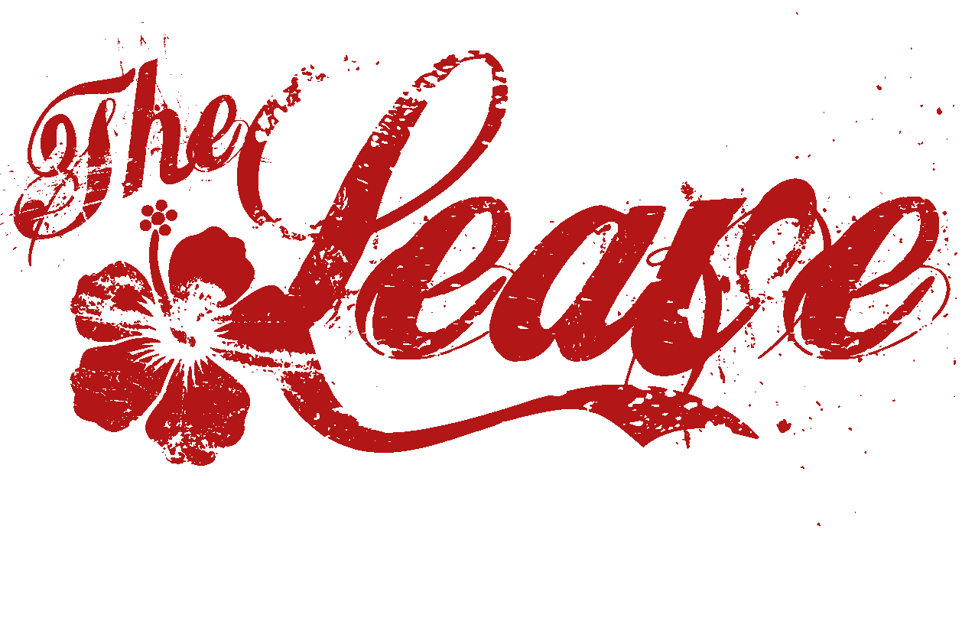
Biography in Brief:
Formed in the spring of 2010, The Leave had an instant chemistry, crafting a unique sound that definitely commands its own sonic elbow room. Comprised of members who have individually toured the Nation having the pleasure of working with some legendary names in music, collectively The Leave are embarking on an audio odyssey of infinite scale. Are you prepared to dance on the beautifully dark, somber side of funky town?
Booking Information:
DS Media
931-261-4269
Booking@funktheleave.com

